Date: / / 2020  Vision  - Promoting the Lean Construction theory, management, practices, and techniques throughout Qatar.  - Support continuing positive transformation of Construction industry to enhance performance, generate value, eliminate waste, increase efficiency, and maximize productivity.  - Provide a platform for collaboration across industry and academia. | 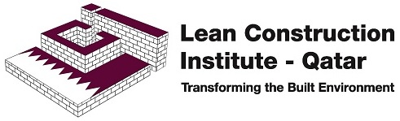 | MEMBERSHIP REGISTRATION FORM
mISSION  - Spread awareness of Lean Construction and Lean Thinking in Qatar.  - Provide the best opportunities to local Lean Construction management professionals and academics who are seeking genuine education, research, training, conferences, knowledge, and networking.  - Establish a platform to share experience, knowledge, lessons learned, and best practices.  - Promote Lean Thinking.  - Supporting the State of Qatar’s 2030 Vision, realizing human development, social development, economic development, and environmental development; by developing businesses and Qatari nationals in the field of engineering and construction management.  Contact  PHONE: (+974) 5547-1277  EMAIL: members@Lci.qa  WEBSITE: https://Lci.qa  MAILING ADDRESS:  Via Protiviti │ Palm Tower B  19th Floor, West Bay  PO Box 13374 │ Doha, Qatar  For LCI-Q Internal Use only  Member Number:  Joining Date: |  | Name  First Name:  …………………………………………………………………………………………..  Last Name:  …………………………………………………………………………………………..  Professional Area of Expertise  Company:  …………………………………………………………………………………………..  Job Title:  …………………………………………………………………………………………..  ☐ Owner(public) ☐ Owner(private) ☐Consultant ☐Contractor  ☐ Subcontractor ☐ Supplier ☐ Academics ☐Student  Contact Details  Email:  …………………………………………………………………………………………..  Mobile:  …………………………………………………………………………………………..  Mailing Address:  …………………………………………………………………………………………..  Membership Category  ☐ Individual(QAR 150/Year) ☐Corporate (QAR 5,000/Year)  ☐ Student(Free)  Interested in ☐LCI-Q WhatsApp Group ☐ Newsletter  Signature……………………………………………………………………………

